**Hutton**



**Football Club** 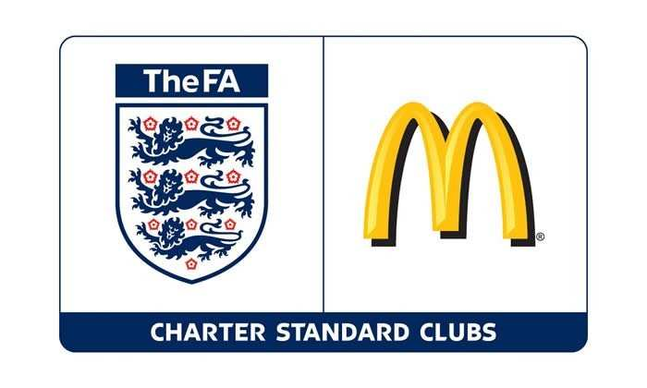

[**www.huttonfc**](http://www.huttonfc)

**Rules of Hutton F.C.**

1. Members are to uphold the good name of the Club at all times, they must act in a sportsman/woman like manner and observe the laws of the game.

2. Members inc Players, Parents, Supporters are to adhere to the Rules of the Astro and School Premises.

**No Smoking on school grounds (this is a school rule)**

**No Dogs on school grounds (this is a school rule)**

**Parents/Supporters are not allowed onto Astro during training and matches, reasons being:**

**\* To let the coach do their job and not confuse the players by telling them what to do**

**(as per FA Respect Code of Conduct).**

* **Health and Safety……to prevent accidents to parents, supporters and any younger siblings, hard kicked footballs can hurt a small child, spilled hot beverages will scald.**
* **Child Welfare…..All our Managers/Coaches are CRB checked and have undertaken appropriate courses in Safeguarding Children and Emergency Aid. It is with the Safeguarding of ALL our young players in mind that we try to prevent any person/s unrelated or unconnected to a player be in close contact with them. This is especially important within the Development section where we have a lot of adults in attendance.**
* **Please note you may enter at the managers/coaches request should your child receive an injury or is visibly upset.**

3. Any fine imposed by any football authority on the Club as a result of misconduct by a club member, be it player, parent or supporter, will be reimbursed by the member to the Club within 14 days of notification of the fine.

4. Any fine imposed by any league on a Team as a result of being unable to fulfil a fixture ( without appropriate notice at the start of playing season ) by a number of players within that team being absent i.e attending same event ( party, school trip etc) will be reimbursed by the members absent to the Club within 21 days of notification of the fine.

5. Any fine imposed by any league/authority as a result of refusing to fulfil fixture for Personal/Player/Parental reason…..i.e opposition is too strong, opposition players/officials/parents were verbally abusive at previous game etc…..Manager to seek advice of Committee first who in turn will seek advice from League. If League states game must be played HFC Committee member/s to be present at game. If HFC Manager/Parents still refuse to fulfil match then HFC Committee will decide who is liable.